International Women's Day: No freedom without diversity and gender equality
Pubblicato il:
Scritto da Erik Albers
Today, the FSFE celebrates International Women's Day, a global day calling for women's rights and gender parity. As in many other communities, women in Free Software communities face gender discrimination on a daily basis. To help improve their environment and raise awareness, the FSFE wants to use today's occasion to share our ongoing efforts to improve gender balance and ensure gender equality.
Gender discrimination is a massive problem throughout history. But it was only in the beginning of the 20th century when first countries started to introduce an International Woman's Day which was adopted by the United Nations in 1975 as a global day of celebration and a focal point in the movement for women's rights. The UN theme for International Women's Day in 2019 is “Think Equal, Build Smart, Innovate for Change” to help put a focus on the role that technological innovation by and for women and girls plays in efforts to achieve gender equality. This theme reminds us of the role of Free Software in achieving self-emancipation and gender equality.
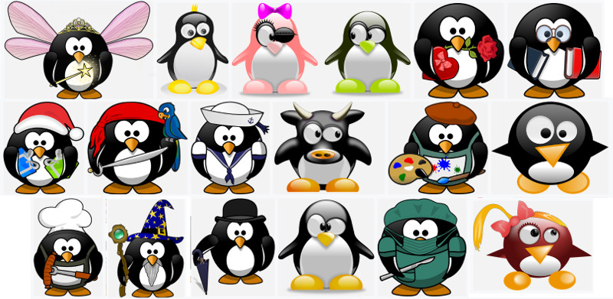
Freedom is all about diversity.
Ever more, technology controls every single aspect of our lives. But women have traditionally been and still are underrepresented in the bodies shaping those technologies that change our society. Core reasons are traditional and exclusive male-driven organisation cultures and the creation of artificial barriers to prevent women's influence on shaping technology the way they see fit. To empower women and achieve true gender equality in our society, it is inevitable to offer women the same access to tinker with technology as man have.
Free Software is technology that respects and empowers any user equally and puts everyone of us in control of technology. This way, the four universal freedoms of Free Software offer fertile soil for emancipating technologies without restrictions towards gender or any other backgrounds. At the Free Software Foundation Europe we are working towards ensuring that women are equally empowered to shape technology, and thereby change society for the better. Some actions that we have taken to achieve this include helping to establish female role models in technology by encouraging female speakers at our events, by balancing gender contributions in our public pictures and statements, and for job applications we give preference to applicants who identify as part of a traditionally marginalised demographic in technology for applications of equal strength.
But problems already arise on a much lower level and unfortunately, taking part in discussions is not always equal for everyone. We can see gender discrimination in nearly all communities, most prominently by people using their dominant positions or attitude to discriminate against or intimidate women. But regardless of how much someone has contributed to discussions with their knowledge, or how well connected they are within our community, or how much they have donated or are planning to donate: discriminatory, disparaging or offensive speech or actions, including as to (but not limited to) gender, sexuality, race, nationality, religion or profession has no place in our community! We are proud to be a community of many different nationalities and backgrounds, and we cherish our strength in diversity.
To further strengthen diversity within the FSFE, we take an active role in establishing a welcoming environment for everyone inside our community. Our staffers and executives are consulting with experts on discrimination and inclusion, and to ensure that in the FSFE all participants can, at all times, feel at ease to participate without fearing any form of attack, reprisal or harassment, we have adopted a Code of Conduct. Any behaviour contrary to the principles enshrined in this Code of Conduct, can and shall be brought to the attention of a respective local or our central CARE team. We are convinced that any case we are being made aware of will help in making the environment more attractive and welcoming for everyone.
The FSFE's mission is to empower people to control technology. To make sure that every human can understand how software works, use the software for any purpose, share it with others and adopt it to their needs, it is crucial that all women can exercise those rights as well to shape technology and create a better society for all of us. We want to contribute our part in balancing the power of who controls technology, and in general contribute to better gender equality inside our own as well as in other Free Software communities. We therefore ask you to join us on this path.

Tag
- CARE team
- Code of Conduct

Condividi e sostieni
Alcuni servizi potrebbero non essere Software Libero e potrebbero pregiudicare la tua privacy. Saperne di più.

Stampa
- Comunicati stampa
- Ultime notizie
- Le basi del Software Libero

Sulla FSFE
La Free Software Foundation Europe è un'associazione che incoraggia gli utenti ad avere il controllo della tecnologia.
Il Software è presente in tutti gli aspetti della nostra vita ed è importante che questa tecnologia ci aiuti anziché limitarci. Il Software Libero garantisce a tutti il diritto di usare, studiare, modificare e condividere il software. Questi diritti aiutano a sostenere altre libertà fondamentali come il diritto di parola, la libertà di stampa e la privacy.
Saperne di più

